Chapter 02: Introduction to SAP

Exercise 02-01: SAP Navigation

Multiple Company Code

Version 4.14

Revised 01/05/2016

Introduction

General Notes and Information

It is strongly recommended that you read through the entire exercise prior to starting. Not all instructions can be provided in a linear manner in the exercise itself. READ CAREFULLY!

The following symbols are used to indicate important information as described below.

* An arrow highlights an important instruction that must not be overlooked.

🖉 A pencil prompts you to write down an important piece of information.

Each student or group will be assigned a unique two digit identifier. This identifier is used in all exercises to uniquely identify your data. Whenever you see two-digit ## in these exercises, replace it with your identifier.

Differences in Font: Throughout this exercise you will see tables with different fonts used in the Data Entry column(s). The normal Times New Roman indicates you enter exactly what is typed out except for the ## Symbol where you would put in your identifier. The italicized *Times New Roman* font indicates the data is looked up, found, or otherwise not to be entered literally as written.

* Always work with your data.
* Provide both the code and its description in your answers. The questions are designed for you to locate the code but also understand the meaning

When you Log onto SAP for the first time you may get a pop-up message regarding copyright information, please accept the terms to continue into SAP.

* From the SAP Logon screen, make sure that you do not click on the (LOG ON) button in the upper left hand corner of the screen. Instead, double-click on the assigned system name.

SAP Menu First Glance

Look through these pictures for a first glance at what some of the most important aspects of SAP look like.

The Standard Toolbar:

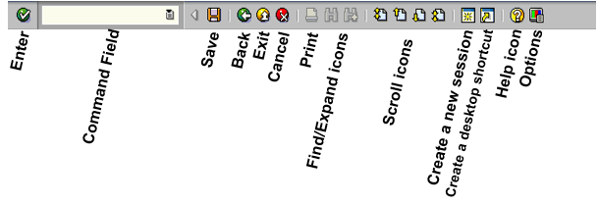

* Examples of Application Menu Bars:

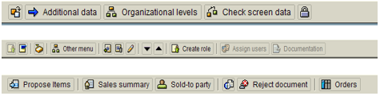

The application menu’s contents depend upon which transaction you are currently using. This menu will appear below the screen name which is just below the standard menu.

Screen Layout:

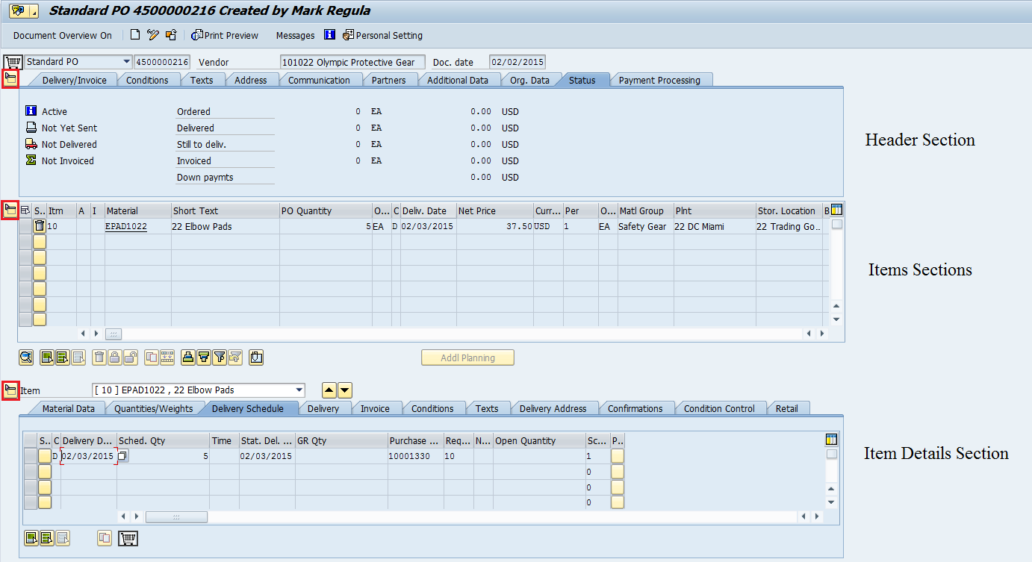

There won’t always be all three sections, but it is important that you understand this general concept.

* You may edit data in any section depending on which sections you have opened or expanded with the buttons outlined in red on the left.

General Important Screen Elements:

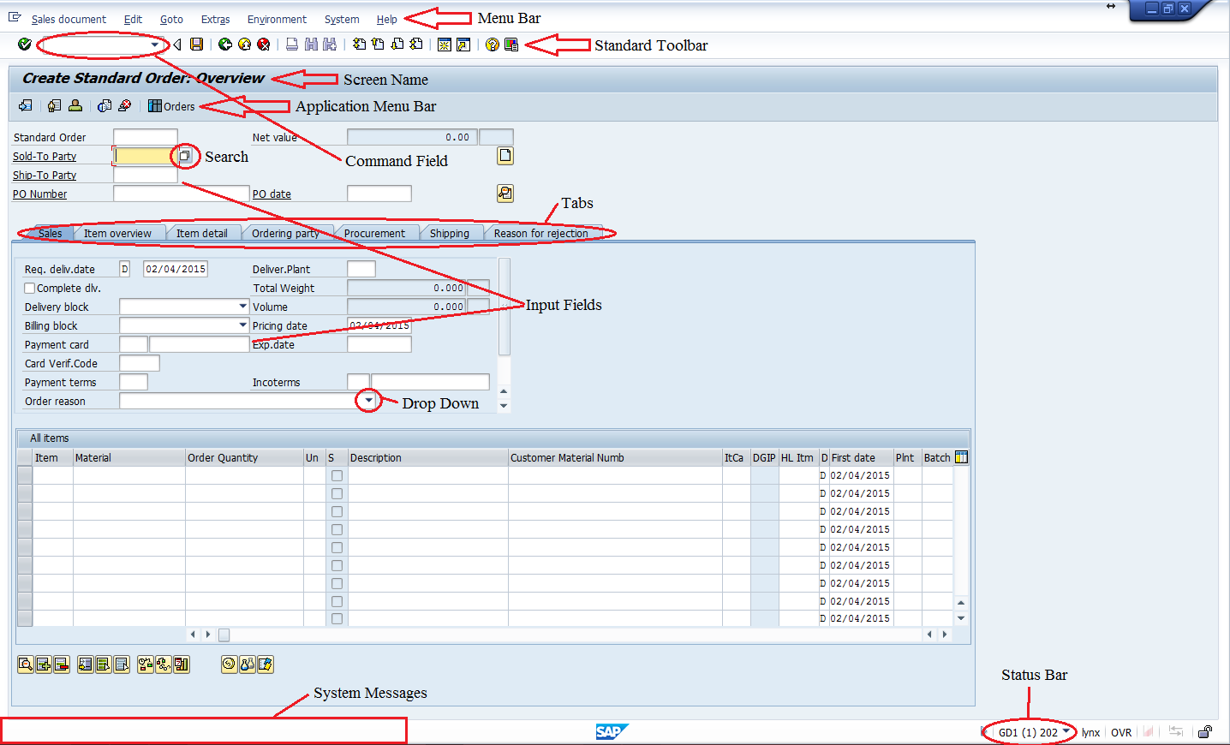

System Messages:







These are examples of an error message, a warning message, and an information message, respectively.

* An error message means there is a critical issue that makes it impossible to continue with your work.
* A warning message serves the purpose of informing you of some important fact that you may not have noticed. These messages, if they are expected, can be ignored. You can continue past them by pressing enter, or by simply ignoring them and moving on with what you were doing.
* The information messages serve as a confirmation that you have completed a task.
* For EVERY one of these messages, you can see VERY HELPFUL information by clicking on them. This will open the “Performance Assistant” pop-up. In the case of errors, ALWAYS CLICK ON THE ERROR to get more information so you may attempt to troubleshoot it yourself.

Business Process Overview

This exercise will help familiarize you with SAP. It will cover navigating in SAP, utilizing the search function, and some other basic functions that will prove useful when performing the rest of the exercises. If you are already familiar with SAP, it will be a nice refresher.

Exercise Prerequisites

There are no prerequisites needed.

Exercise Workflow

Exercise Deliverables

Deliverables are consolidated into one worksheet at the end of the exercise. It is only necessary to turn in that worksheet and that worksheet alone along with data in the system if required.

For this exercise you will need the following deliverables:

In the System:

* None

On Paper:

* Answer(s) to Question(s)
* You may be assigned additional deliverables. Make certain to check with your instructor.

Step 1: Navigating SAP

In this step, you begin to navigate SAP through the SAP menu. This menu contains all the functionalities of SAP. They are broken up according to business functions. Within all GBI exercises, a navigation path similar to the one below will guide you through the menu. This first exercise will show you how to view the accounts receivable balance for a customer.

1. In the “SAP Easy Access” screen, follow the navigation path below:

Navigation

Accounting 🡪 Financial Accounting 🡪 Accounts Receivable 🡪 Account 🡪 Display Balances

* To actually enter the transaction, double-click on Display Balances within the navigation.
* In later exercises you enter information within the fields. However, for this exercise, you do not enter any information. Instead, you view the displayed data within the system.
* You will use this transaction in later exercises. When you do this, you will enter the customer’s identification number, a company code, and the current fiscal year to identify the customer’s accounts receivable balance. Remember this for future exercises.

1. You are now in the “Customer Balance Display” screen, now answer the following questions.
2. In the “Customer Balance Display” screen, look to the left side of the input fields, what is the first field called? Customer 🖉
3. What is the second field in the screen called? Company code 🖉
4. What is the third field in the screen called? Fiscal year 🖉
5. Click on  (EXIT).

* To exit using another method, type “/n” into the 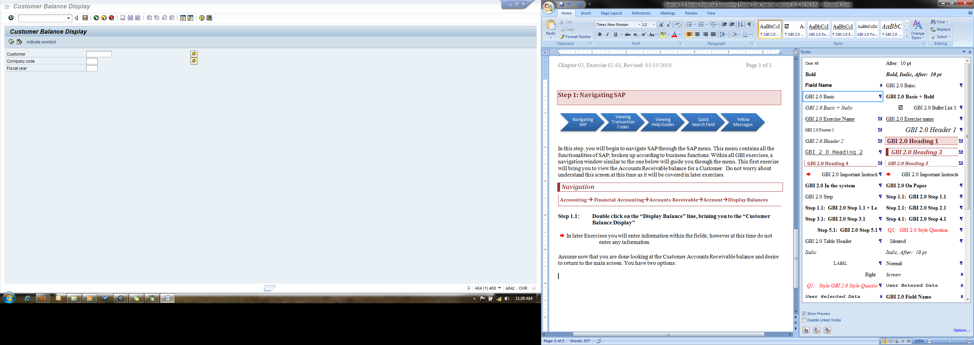 field (the command field) at the top and click on the  icon. This will bring you back to the main screen.
* Keep this information on hand as you work through future exercises.

1. What does the “/n” command do? turn back to main screen 🖉

Exercise Deliverables

In the System:

* None

On Paper:

* Answer(s) to Question(s)

Step 2: Viewing Transaction Codes

In this step, you continue navigating through the SAP menu. However, instead of using the drop down menu, you will use transaction codes to pull up a specific window. In this step, you will learn how to find the transaction codes, how to use these codes, and how they are useful.

1. In the “SAP Easy Access” screen (at the top), click on Extras.
2. Click on Settings.
3. In the “Settings” pop-up, ensure that “Display technical names” is selected.
4. Click on  (CONTINUE (ENTER)).
5. In the “SAP Easy Access” screen, follow the navigation path below:

Navigation

Accounting 🡪 Financial Accounting 🡪 Accounts Receivable 🡪 Account 🡪 Display Balances

* DO NOT double-click on Display Balances.
* Before clicking on the line, notice additional information has been included before the name. This is the transaction code to enter to proceed to the “Customer Balance Display” screen.
* If you double-clicked on Display Balance, before you wrote down the transaction code, use the green arrow C:\Users\Lauren\Dropbox\ERP Inititive\Folder 05\SAP Icons\S_F_BACK.gifto go back to the menu to see the transaction code.

1. What is the transaction code for the *“Customer Balance Display”* screen? FD10N 🖉
2. Click on 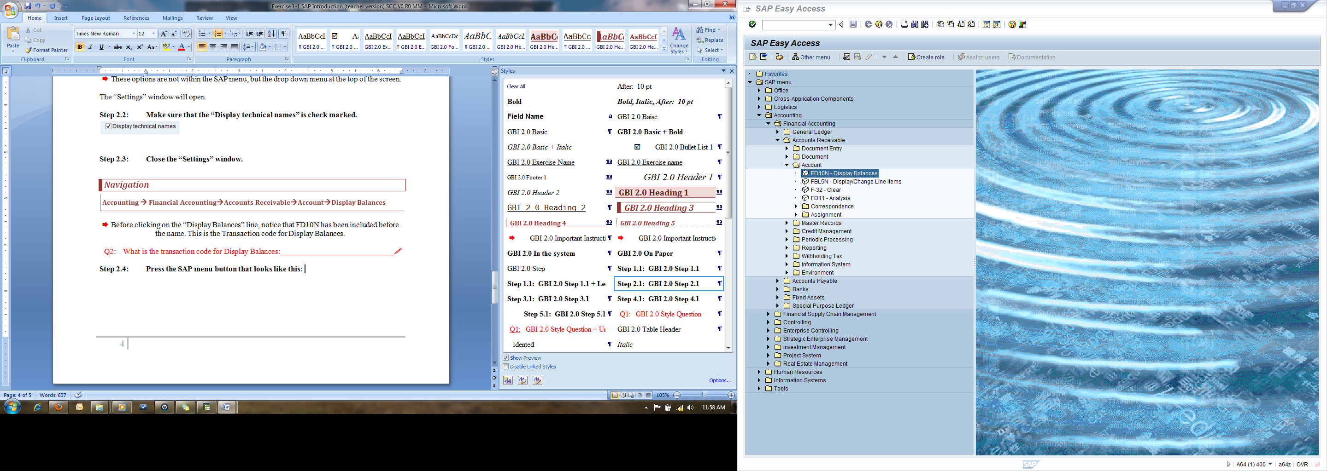 (SAP MENU).

* Pressing this button will close the folders and return the SAP menu to the original status.

1. Why is the SAP menu button helpful? Close all tabs fast 🖉
2. Type the Customer Balance Display transaction code in the  field (the command field) and press on the “Enter” key to proceed to the “Customer Balance Display” screen.
3. Why is typing in a transaction code into the field helpful? Go directly to the transaction we want. 🖉
4. Who would most likely use this feature? User 🖉

Exercise Deliverables:

In the System:

* None

On Paper:

* Answer(s) to Question(s)

Step 3: Viewing Help Guides

In this step, you learn how to use the “Performance Assistant” tool to help you find answers to error messages or to find the definition or explanation of a field within the SAP system.

1. In the “SAP Easy Access” screen, follow the navigation path below:

Navigation

Accounting 🡪 Financial Accounting 🡪 Accounts Receivable 🡪 Account 🡪 Display Balances

1. In the “Customer Balance Display” screen, click on the “Customer” field.

* Do not enter any customer information in the field.

1. Press on the “F1” key on your keyboard.
2. What is the “Account Number” definition? Customer Account Number 🖉
3. In the “Performance Assistant” pop-up, click on the  (CLOSE) icon.
4. In the “Customer Balance Display” screen, click on the 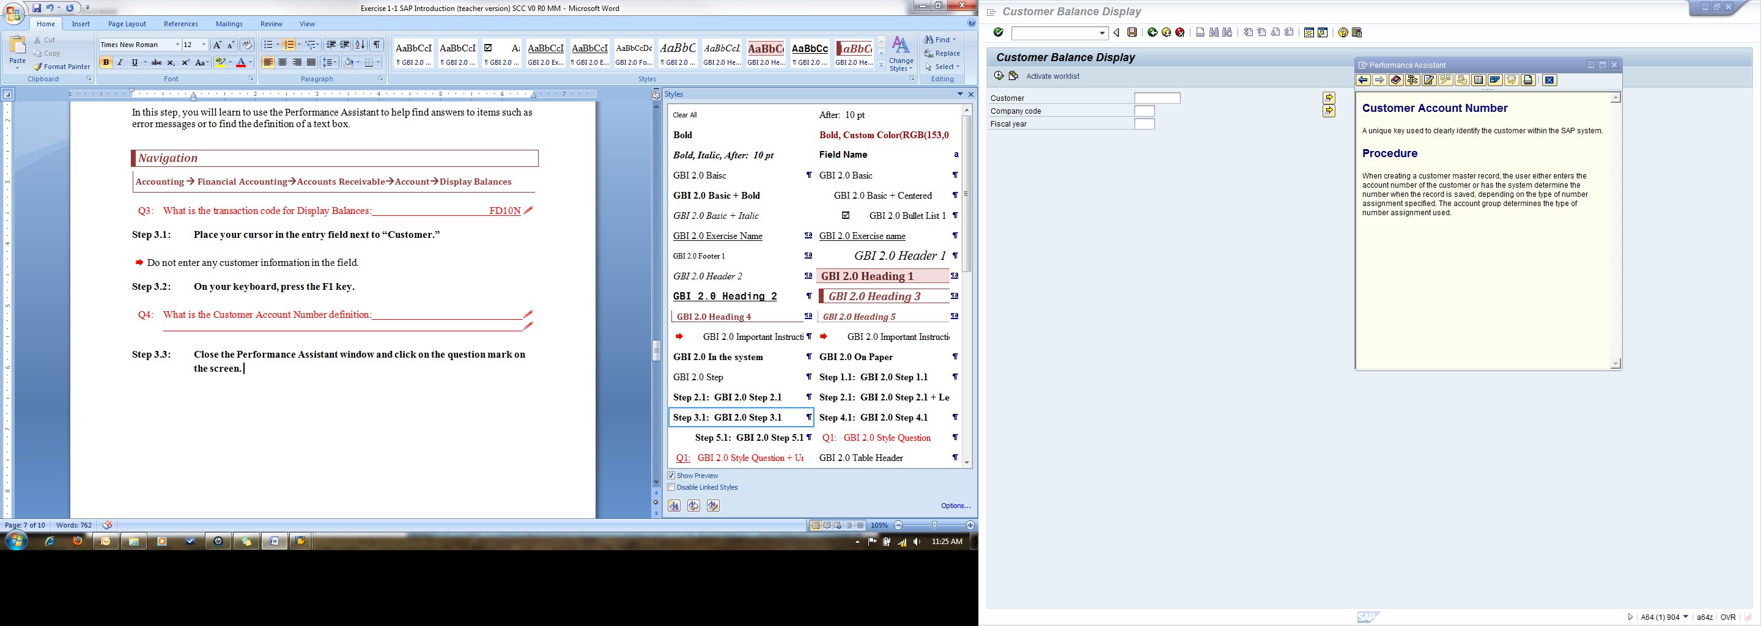(HELP) icon.

* Notice that performing either one of these actions displays the “Assistant” tool.
* In some cases, while using the web GUI you can right click on a field to get help.

1. Close the “Performance Assistant” pop-up and return to the main menu.

Exercise Deliverables:

In the System:

* None

On Paper:

* Answer(s) to Question(s)

Step 4: SAP Search Menu

Before this step, you accessed the “Customer Balance Display” screen by navigating through the menu path and using a transaction code. In this step, you will learn how to use the SAP search menu. The search menu enables you to find a specific page by searching key words.

1. In the “SAP Easy Access” screen, type “search\_sap\_menu” in the command field.

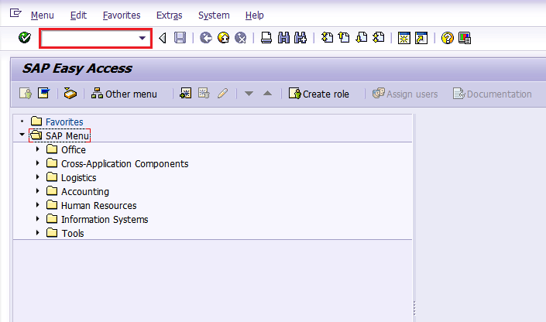

1. Click on  (ENTER).
2. In the “Enter transaction code” pop-up, enter the following information:

|  |  |
| --- | --- |
| Field Name | Data Entry |
| Search text entry | Display Balances |

1. Click on  (CONTINUE (ENTER)).

* This will bring up another screen that will list all of the locations “Display Balances” appears in the SAP menu. Use the scroll bar on the right side of the screen to see all the available options. Notice that you can access the same screen by using different transaction codes. The reason for this is that multiple job positions may have to access this information (accountants, sales representative, credit managers, etc.). The seventh on the list is the transaction code that you have used in this exercise thus far within the system.

1. What is this seventh transaction code? FK10N 🖉
2. How many different menu paths can you use to display balances? 3 🖉
3. Return to the main menu and repeat steps 4.1-4.3 and in 4.3, enter the following information:

|  |  |
| --- | --- |
| Field Name | Data Entry |
| Search text entry | Material Master |

1. What is the first transaction code? VE81 🖉
2. What is the reason that there are so many menu paths that you can use to access the same transaction? Sometimes, user couldn't remember the transaction ID, or they couldn't remember name of transaction or they forget the path to go to the transaction they want. 🖉

Exercise Deliverables:

In the System:

* None

On Paper:

* Answer(s) to Question(s)

Step 5: Using the Search Box

In this step, you will practice using the search box that appears next to a field when entering data into it. You will also learn how to navigate and use the proceeding menus and pop-ups.

Navigation

Accounting 🡪 Financial Accounting 🡪 Accounts Receivable 🡪 Account 🡪 Display Balances

1. In the “Customer Balance Display” screen, click inside the “Customer” field.

* Notice the box that appears next to the field.



1. Click this box.
2. In the “Customer Account Number” pop-up, enter the following information:

|  |  |
| --- | --- |
| Field Name | Data Entry |
| Maximum No. of Hits | 5000 |

1. Leave all the other fields blank and click (START SEARCH).

* Ensure that the “Customers (general)” tab is selected at the top.
* This will show you a list of nearly all (5000, which is the maximum SAP will allow for search results) of the customers that are defined in the system.
* Notice the many different tabs, which are many different ways of giving search criteria. You can scroll through them using the arrow buttons at the top right.

1. Why might someone use this method of searching with no specific criteria? They don't know specific information or they want to take an overview of the clients who have similar information. 🖉
2. Click the yellow bar near the top of the screen to show the search screen.

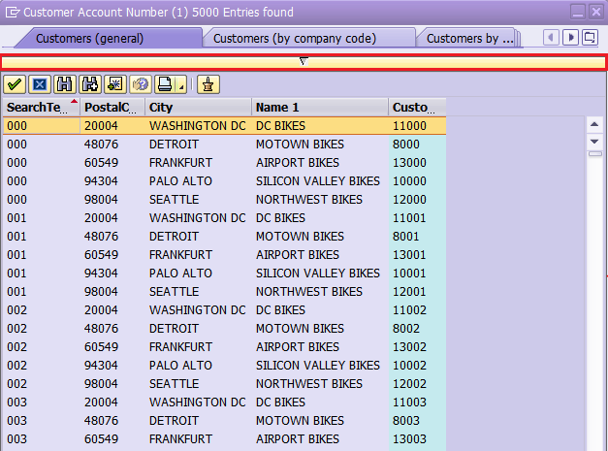

1. This time, enter the following data:

|  |  |
| --- | --- |
| Field Name | Field Value |
| Search Term | 0## |
| Maximum No. of Hits | 500 |

1. Leave all the other fields blank and click (START SEARCH).

* This will show you a list of every customer associated with your identifier. This is by design. Every one of your customers, when they were created in the system, was assigned a three-digit search term that corresponds to your identifier, thus you entered 0## in the “search term” field. This will also work with vendors in future assignments.

1. Click the yellow bar near the top of the screen to show the search screen.
2. Click the button at the very top right corner that looks like this: .

* This menu allows you to use other methods of searching for what you want.

1. Choose “Customers (by company code).”

* You can accomplish the same result by navigating to whichever tab you want using the arrow buttons  and clicking on the tab at the top.

1. In the “Customer Account Number” pop-up, enter the following information:

|  |  |
| --- | --- |
| Field Name | Field Value |
| Company Code | US## |

1. Click (START SEARCH).

* This will show you a list of all (limited to 500) of the customers associated with the US## company code.

1. Click the yellow bar near the top of the screen to show the search screen.

* Clear the “Company Code” field.

1. In the “Customer Account Number” screen, enter the following information:

|  |  |
| --- | --- |
| Field Name | Field Value |
| Customer | \*0## |

1. Click (START SEARCH).

* The asterisk symbol represents a wild card, meaning anything can be before 0##. This will show you a list of every customer that has a customer number ending in your identifier.

1. Why would someone use the “\*” in a search? Because they don't know what information stands for that position 🖉

* Now that you know the various methods of searching, try using other criteria and exploring different searching methods to familiarize yourself with the system.

Exercise Deliverables:

In the System:

* None

On Paper:

* Answer(s) to Question(s)

Step 6: System Message Exercise

This step will help to familiarize you further with the different system messages by having you produce each type and figure out how to get past it.

Navigation

Logistics 🡪 Materials Management 🡪 Purchasing 🡪 Purchase Order 🡪 Create 🡪 Vendor/Supplying Plant Known

1. In the “Create Purchase Order” screen, enter the following information:

* Go ahead and close the user interface pane in the left side of the screen if it opens up.
* Remember what was said above about the different sections of the screen. You may have to open an additional section and explore the tabs to find this field.

|  |  |
| --- | --- |
| Field Name | Data Value |
| Purch. Org. | US## |

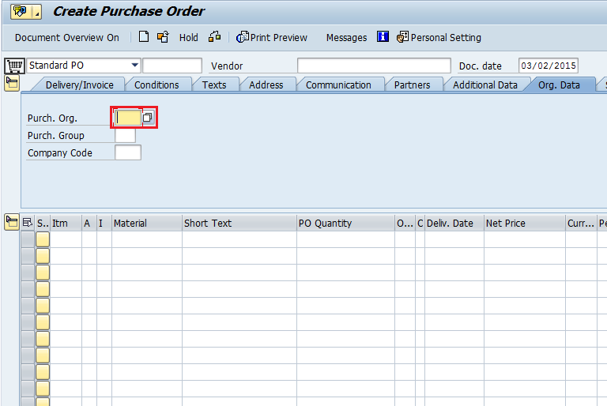

1. Click (ENTER).

* NOTE: Once you click the enter button or press “enter” on your keyboard, the system checks to ensure that you have entered all the data that is required to proceed. If you haven’t, it will ask you to enter valid data into each field, ONE BY ONE. After entering data into the field, you must PRESS ENTER AGAIN to move onto the next field. Once you have filled in all the required information, the rest of the fields in the screen will unlock and you can edit them as you could before you initially clicked enter. In this case, the other fields may never have locked but it is important to understand this concept for later exercises.
* Notice that the system shows an error message which, in this case, simply tells you exactly what you need to enter next.

1. When you receive the error message “Enter Purch. Group”, enter the following information:

|  |  |
| --- | --- |
| Field Name | Data Value |
| Purch. Group | N## |

1. Click (ENTER).
2. When you receive the error message “Enter a vendor” enter the following information:

|  |  |
| --- | --- |
| Field Name | Data Value |
| Vendor | 101000 |

1. Click (ENTER).

* Notice here how it does not produce another error message and you are now free to edit the rest of the fields as you wish. This means you have entered all the required data.

1. In the “Create Purchase Order” screen, enter the following data:

* If the “Item Overview” section isn’t open, you will have to open it and enter this data there.

|  |  |
| --- | --- |
| Field Name | Data Value |
| Material | EPAD1000 |
| PO Quantity | 1 |
| Delivery Date | Today’s Date |
| Net Price | 37.50 |
| Plnt | MI## |

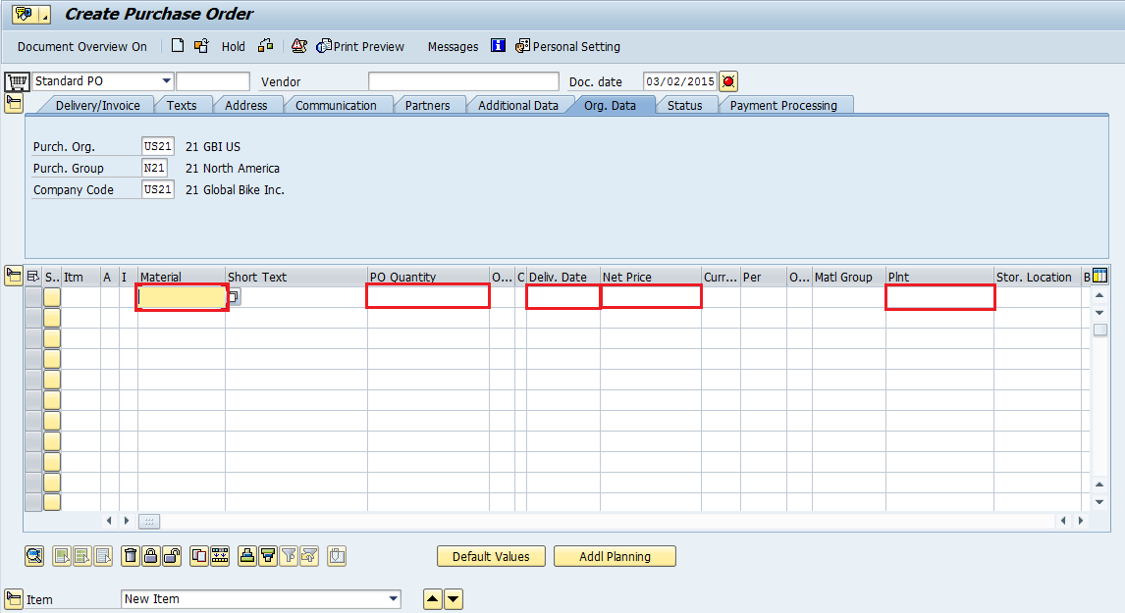

1. Click (ENTER).

* You should notice a warning message saying “Can delivery date be met?” The system realizes that the date you entered is today’s date, and it knows it normally takes more time than that to receive materials. This message serves the purpose of warning you about that fact, but since it is just a warning, you may ignore it and continue.

1. Click (ENTER) to acknowledge the warning and move on.
2. Click (EXIT).
3. In the “Exit Document” pop-up, click (NO).

* DO NOT save this document. The purpose of this exercise was to familiarize you with these two types of system messages, not to actually create a document. That is done in later exercises.
* When you are finished with this assignment, you may exit the SAP GUI by clicking the  button at the top right of the screen or by repeatedly clicking the (EXIT) button. You will receive a pop-up, click  to log off.

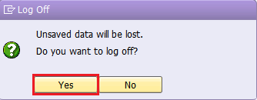

* Remember, it is extremely important to NOT proceed and save a document if there are errors in the document. A faulty document will create more errors and a lot more work for yourself in later exercises.

Attachment 1: Exercise Worksheet

Name: Thuy Hong Ha

Course and Section: Introduction to SAP

Identifier: 54

Client: 517

* Provide both the code and its description in your answers. The questions are designed for you to locate the code but also understand the meaning

1. In the “Customer Balance Display” screen, what is the top field called? 🖉
2. What is the second field in the screen called? 🖉
3. What is the third field in the screen called? 🖉
4. What does the “/n” command do? 🖉
5. What is the transaction code for the *“Customer Balance Display”* screen? 🖉
6. Why is the SAP menu button helpful? 🖉
7. Why is typing a transaction code into the field helpful? 🖉
8. Who would most likely use this feature? 🖉
9. What is the “Account Number” definition? 🖉
10. What is this seventh transaction code? 🖉
11. How many different transaction codes can you use to display balances? 🖉
12. What is the first transaction code? 🖉
13. What is the reason that there are so many menu paths that you can use to access the same transaction? 🖉
14. Why might someone use this method of searching with no specific criteria? 🖉
15. Why would someone use the “\*” in a search? 🖉